Course: ENSF 337 - Fall 2020

Lab #: 1

Instructor: M. Moussavi

Student Name: Alexander Sembrat (30089188)

Lab Section: B01

Submission Date: September 17th 2020

Part B:

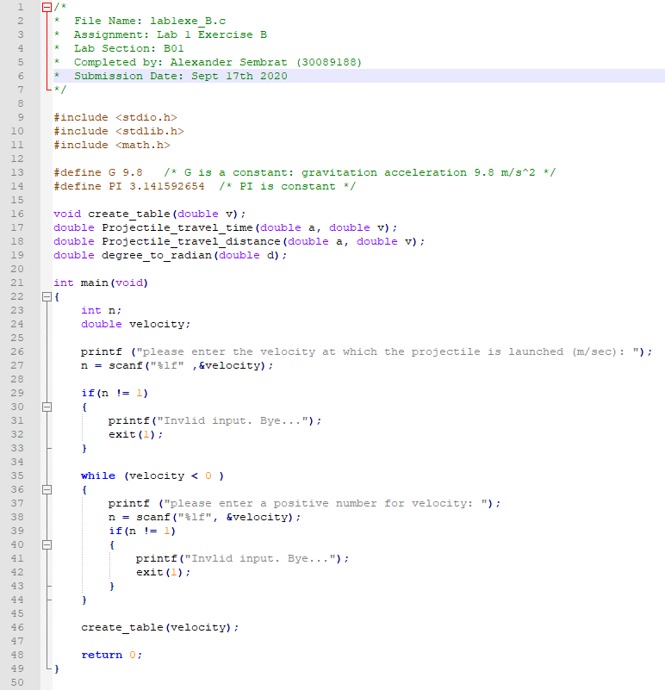

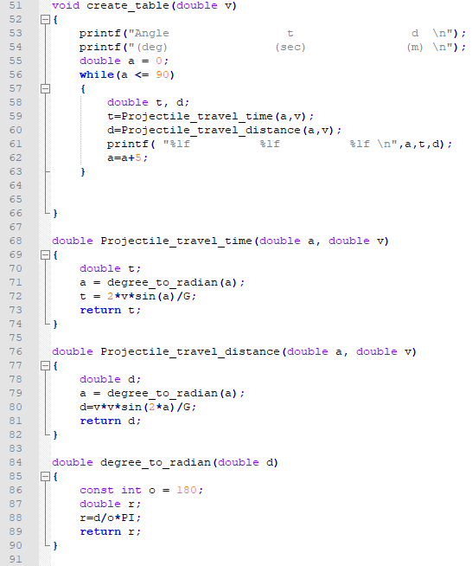

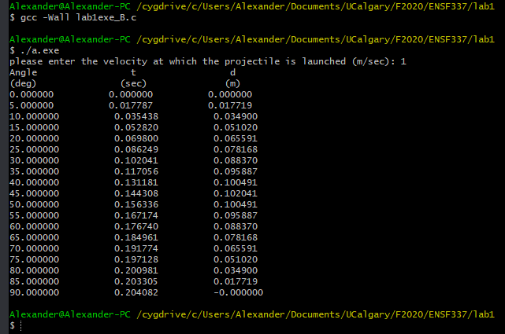

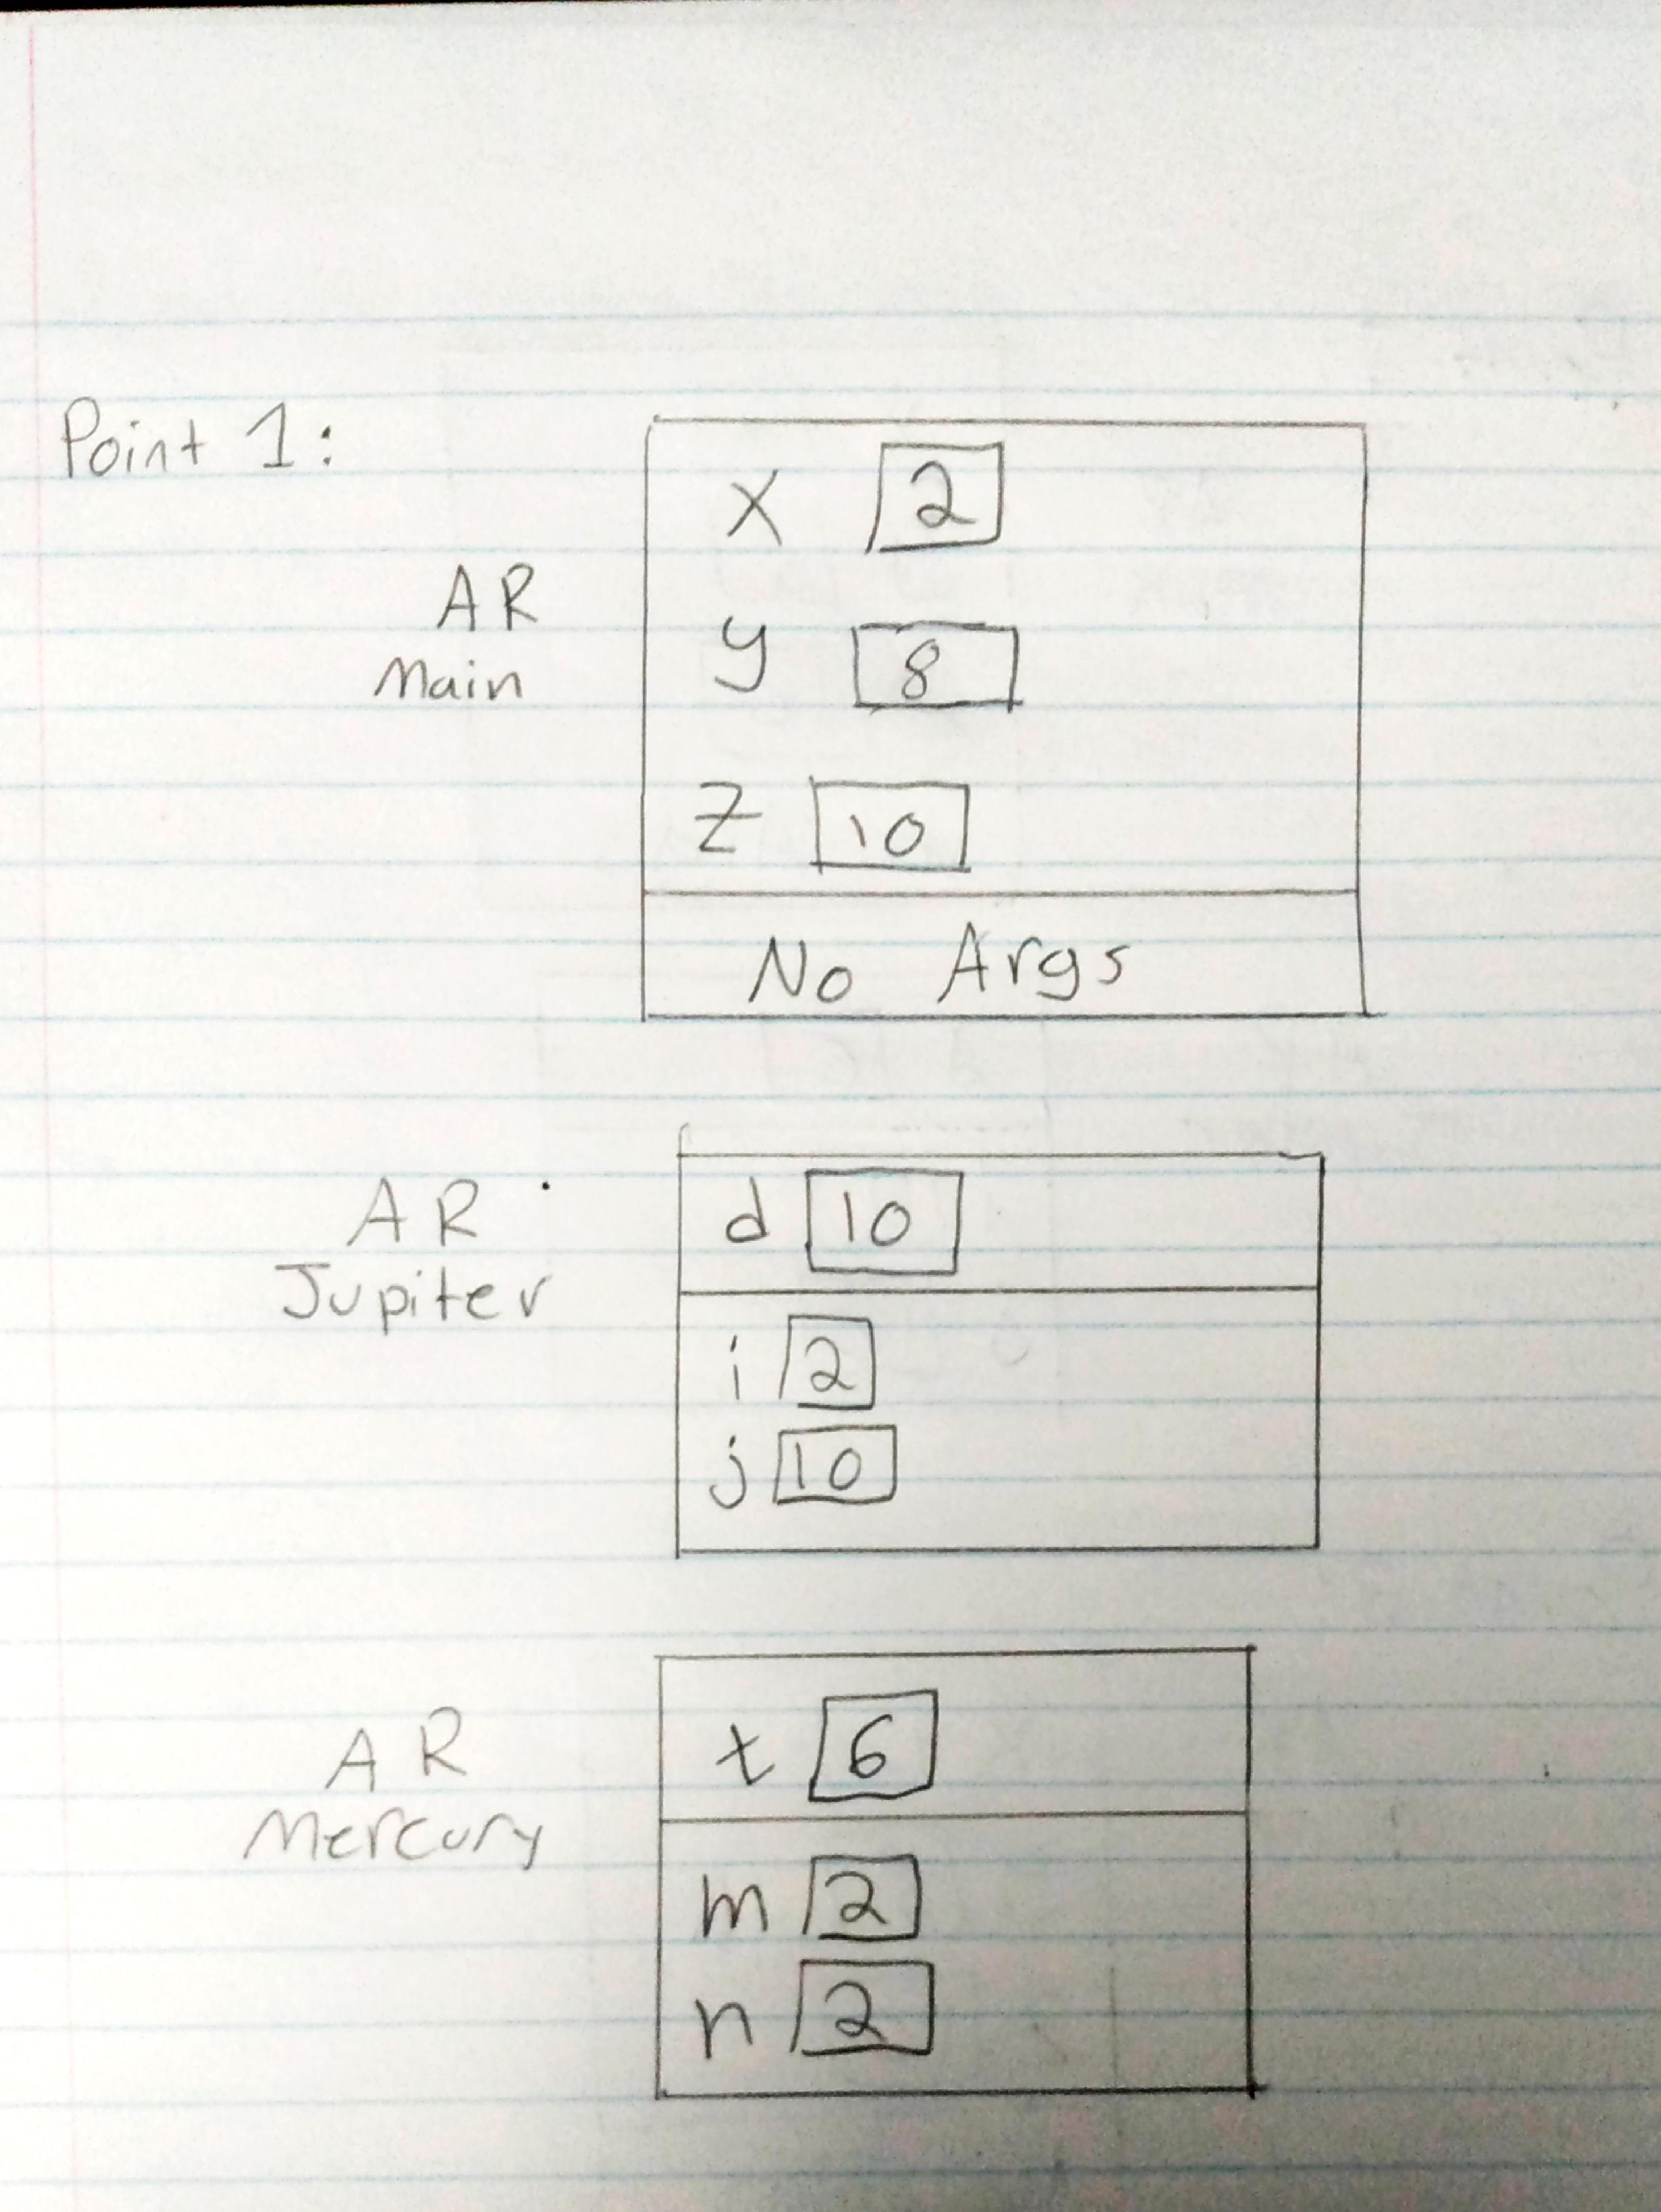Part C:

